**Q4. Troubleshoot Ethernet Communication with ping and traceroute using Cisco Packet Tracer. Create a simple LAN setup with two Linux machines connected via a switch. Ping from one machine to the other. If it fails, use ifconfig to ensure the IP addresses are configured correctly. Use traceroute to identify where the packets are being dropped if the ping fails.**

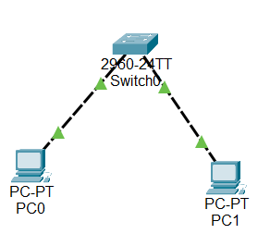

**On providing an incorrect ip, the packet is lost .To find the lost packet we use traceroute:**

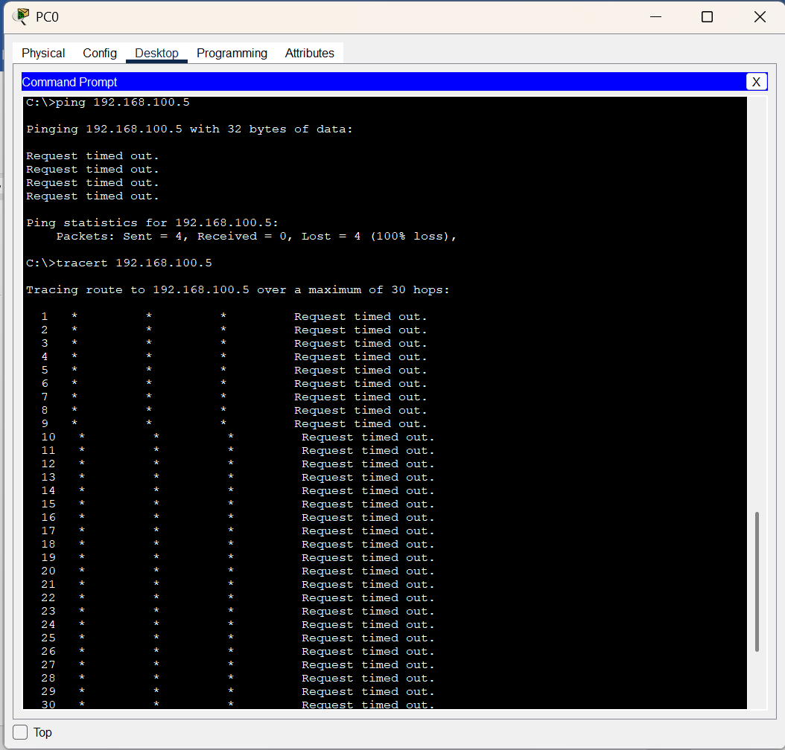

**On resolving ,**

